**Architecture of the Automation process:**

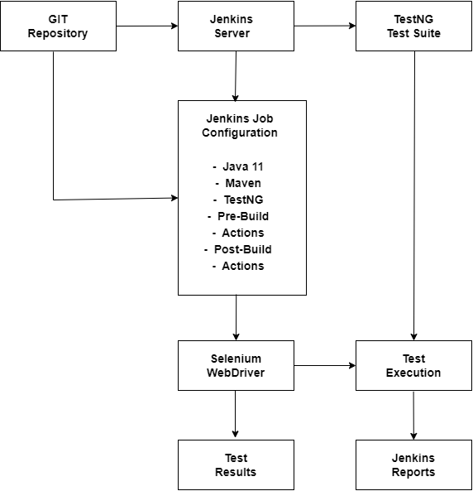

**Prerequisites:**

* An AWS account
* An EC2 instance running a compatible OS (e.g., Amazon Linux, Ubuntu)
* Jenkins installed on the EC2 instance
* Java Development Kit (JDK) 11 installed
* Git installed on the EC2 instance
* TestNG and Selenium dependencies configured in your project
* Maven installed

**Setup Instructions:**

1. Launch an EC2 Instance:

* Go to the AWS Management Console.
* Launch a new EC2 instance with your preferred OS.
* Configure security groups to allow SSH (port 22) and HTTP (port 8080 for Jenkins).

1. Install Jenkins:

* Connect to your EC2 instance via SSH.
* Follow the official Jenkins installation guide for your OS: [Jenkins Installation.](https://www.jenkins.io/doc/book/installing/)
* Start the Jenkins service and ensure it is running.

1. Configure Jenkins:

* Open your web browser and navigate to http://<your-ec2-instance-public-ip>:8080
* Complete the initial setup steps, including installing recommended plugins.
* Create an admin user.

1. Install Java 11:

* Install Java 11 on your EC2 instance.
* Configure Jenkins to use Java 11 by navigating to Manage Jenkins > Global Tool Configuration and adding JDK installations.

1. Install Maven:

* Install Maven on your EC2 instance.
* Configure Jenkins to use Maven by navigating to Manage Jenkins > Global Tool Configuration and adding Maven installations.

1. Setup Jenkins Job:

* Create a new Jenkins job and configure it to pull the code from your Git repository.
* **Pre-Build Actions:** Add any necessary pre-build steps such as code quality checks or environment setup.
* **Build:** Add build steps to execute your TestNG test suite using Maven.
* **Post-Build Actions:** Configure post-build actions to generate and display test reports using TestNG.

1. Install and Configure Selenium WebDriver:

* Ensure your project dependencies include Selenium WebDriver.
* Configure your test suite to use Selenium WebDriver for browser automation.

1. Running the Tests:

* Trigger the Jenkins job manually or configure it to run on code changes (e.g., using webhooks).
* Monitor the job progress and view test results and reports directly in Jenkins.

**Repository Structure:**

* **Jenkinsfile:** Contains the pipeline script for Jenkins.
* **src/test/java:** Contains the TestNG test suite.
* **pom.xml or build.gradle:** Contains the project dependencies including TestNG and Selenium.